UNIVERSITY OF HAWAII
INSTITUTE FOR ASTRONOMY
2680 Woodlawn Dr.
Honolulu, HI
96822
NASA Infrared Telescope Facility
TCS Spare Motor Analysis

Eric Warmbier

July 30, 2026

1 Executive Summary 3
2 Introduction 3
3 Description of Motors, Drivers, and Velocity 3
3.1 Motors 3
3.2 Power Amplifiers 3
3.3 TCS Maximum Current and Torque 3
3.4 TCS Maximum Motor Velocity in TCS 4
4 Motor Parameter Comparison 4
4.1 Peak Torque 4
4.2 Peak Torque Voltage and Current Requirements 4
4.3 Back EMF Effects and Driver Margin 4
4.4 Inductance and Response 6
4.5 Torque Ripple 7
5 TCS Modification for Spare Motor 7
6 SIMULINK 8
7 Summary 9
8 Appendix A 10
9 References 17

Figure 1 Stall and 2000 arcsec/s Torque vs. Time for Original and Spare Motors 6
Figure 2 TCS1 SIMULINK Model with Highlighted Blocks Showing Modifications 7
Figure 3 Velocity Control Model with Highlighted Blocks Showing Modifications 8
Figure 4 Current TCS1 System SIMULINK Model with Original and Spare Motor 9
Figure 5 TCS1 System SIMULINK Model with Original and “tuned” system for Spare Motor 9
Figure 6 Actual TCS1 SLEW Operation, Velocity and Current 10
Figure 7 Spare Motor Datasheet (“A” version) 11
Figure 8 Original Motor Datasheet (“A” version) 12
Figure 9 Offset 30 arcsec/s: SIMULINK model of Original and “Tuned” Spare Motor 13
Figure 10 Offset 30 arcsec/s: SIMULINK model of Original and Spare Motor (“not tuned”) 14
Figure 11 Offset 30 arcsec/s: SIMULINK of Original and “Tuned” Spare Motor Torque 15
Figure 12 Offset 30 arcsec/s: SIMULINK of Original and Spare Motor Torque (“not tuned”) 16

Executive Summary
The spare motors for the telescope axis control appear to be acceptable replacements. No major issues were found when analyzing the use of the spare motors in the telescope system when two simple adjustments are made to the motor velocity control loop. Motors were not actually tested in the system.

Introduction
A set of spare motors for a telescope axis was purchased in 2003. During the Telescope Control System One (TCS1) SIMULINK modeling review on November 29, 2007, an action item was created to analyze these motors and determine if any issues could be found regarding their use in the TCS. The datasheet parameters will be compared between the motors and then the SIMULINK model for TCS will be run using the replacement motor parameters. The output of the simulations will be analyzed for overshoots, oscillations, excessive settling, etc.

Description of Motors, Drivers, and Velocity

Motors
Both the original and replacement motors are DC motors made by Kollmorgen. The original motors are model T-12016. They are believed to be version “A” based on the 1 ohm measurements taken across the motor windings which corresponds to version “A” on the datasheet. There are no plates specifying the part number and there is no documentation specifying which motor version it is. The original motors were made in the 1970s. The replacement motors are model QT-12505A.

Power Amplifiers
The power amplifiers are CSR Contraves NC307 amplifiers with a +90V supply and 105 amps peak current and 35 amps continuous. The current will ultimately be limited by the +90V supply (including tolerance) and the DC resistance of the motor. If the tolerance of the +90V ever became an issue, the supply could either be adjusted or replaced.

The amplifier may be capable of 105 amps maximum, however, a 1 ohm resistor is placed in series with the amplifier output to the motor. Excluding the motor winding resistance, the maximum current would be limited to 90V/1Ω=90A. Including the winding resistance will lower the maximum current that is available.

TCS Maximum Current and Torque
The maximum current observed during TCS operation is during a SLEW. This is the mode where maximum velocity and acceleration is experienced, requiring the most current.

Data recorded from a TCS1 SLEW (Figure 6) shows a maximum pulse current of approximately 30 A during acceleration/deceleration and a continuous current during the SLEW of approximately 7 A.

Using the torque constant of 3.90 lb-ft/amp for the T-12016A, this equates to (3.90 lb-ft/amp x 30 A) 3.117 lb-ft of torque maximum during acceleration/deceleration and 27.3 lb-ft of torque continuously during the SLEW. This torque is calculated at the rotor shaft, not after the bull gear ratio.

TCS Maximum Motor Velocity in TCS
Motor velocity may be an important consideration since this creates back EMF which effectively reduces the voltage across the motor. Lowering the voltage also limits the current which ultimately limits torque.

The maximum velocity of the telescope is roughly 2000 arcsec/s or 1.40 rad/s at the rotor shaft including the bull gear ratio.

Note: TCS1 has recorded speed of 2800 arcsec/s, however TCS3 will have a target speed around 2000 arcsec/s.

Motor Parameter Comparison

Peak Torque
Peak Torque for each motor is 200 lb-ft. They are equivalent in this regard. However, data from the TCS1 does not show the system ever requiring the maximum torque.

Peak Torque Voltage and Current Requirements
The original motor reaches peak torque at 50V and 51A, which is within the 90V and the 105 amp peak of the NC307. This motor cannot be run continuously at max torque with the NC307 continuous current rating of 35 amps. As stated earlier, the maximum recorded current is 30 amps during operation peak and 7 amps continuous. Including the 1 ohm resistor mentioned above and the 0.97 ohm DC resistance of the motor, peak current is actually reduced to (90V/1.97Ω) 45.69 A. The original motor is not able to reach peak torque in the current TCS system, however, it has not been required.
The spare motor reaches peak torque at 70V and 15A, which is also within the 90V and the 105 amp peak of the NC307. Therefore, the maximum torque can be achieved with the current system using the spare motors.

Back EMF Effects and Driver Margin
The back EMF reduces the voltage as discussed above. For the original motor at a SLEW speed of the recorded 2800 arcsec/s, the back EMF is:
$$\begin{aligned}{\text{Back}}_{{\text{EMF}}_{\text{Orig}}}={\text{tel}}_{\text{vel}}(\text{arc}\text{sec/}s)⋅\frac{{\text{rad}}/s}{\text{206264}\text{.}\text{81 arcsec/s}}⋅{\text{Gear}}_{\text{Ration}}⋅{\text{Back}}_{\text{EMF}} \\ {\text{Back}}_{{\text{EMF}}_{\text{Orig}}}=\text{2800}(\text{arc}\text{sec/}s)⋅\frac{{\text{rad}}/s}{\text{206264}\text{.}\text{81 arcsec/s}}⋅\text{144}⋅\frac{5\text{.}\text{30}V}{{\text{rad}}/s} \\ {\text{Back}}_{{\text{EMF}}_{\text{Orig}}}=\text{10}\text{.}\text{36}V\end{aligned}$$
At maximum SLEW speed, the maximum available voltage is 90V - 10.36V = 79.64V. The maximum current is limited to 79.64V/(1Ω+0.97Ω)= 40A. This is above the 35 amp maximum drive, so 35 amps are available to continuously drive the motor. With a maximum recorded current draw of around 7A for a TCS1 HA SLEW, there is ((35A/7A) -1)*100 = 400% current drive margin for a SLEW. For the worst case of 30A during an acceleration/deceleration, there is (40A/30A-1)*100 = 33% margin.
The spare motor has a significantly larger back EMF. Assuming 2000 arcsec/s for the velocity, the back EMF is:
$$\begin{aligned}{\text{Back}}_{{\text{EMF}}_{\text{Spare}}}={\text{tel}}_{\text{vel}}(\text{arc}\text{sec/}s)⋅\frac{{\text{rad}}/s}{\text{206264}\text{.}\text{81 arcsec/s}}⋅{\text{Gear}}_{\text{Ration}}⋅{\text{Back}}_{\text{EMF}} \\ {\text{Back}}_{{\text{EMF}}_{\text{Spare}}}=\text{2000}(\text{arc}\text{sec/}s)⋅\frac{{\text{rad}}/s}{\text{206264}\text{.}\text{81 arcsec/s}}⋅\text{144}⋅\frac{\text{17}\text{.}4V}{{\text{rad}}/s} \\ {\text{Back}}_{{\text{EMF}}_{\text{Spare}}}=\text{24}\text{.}\text{29}V\end{aligned}$$
There is no recorded data for the current using the spare motor since it has never been used in operation. Therefore, the current will need to be calculated. Assume the worst case scenario in TCS1 during acceleration/deceleration. In this scenario the maximum torque is applied until the telescope axis reaches SLEW speed. Maximum torque and maximum speed are present at this point.
$$\begin{aligned}\text{Torque}={\text{Torque}}_{\text{cons}}\text{tan}t⋅\text{current}\text{_max} \\ \text{current}\text{_max}=\frac{\text{Torque}}{{\text{Torque}}_{\text{cons}}\text{tan}t} \\ \text{current}\text{_max}=\frac{\text{117}\text{lb}⋅\text{ft}}{\frac{\text{12}\text{.}8\text{lb}⋅\text{ft}}{A}} \\ \text{current}\text{_max}=9\text{.}\text{14}A\end{aligned}$$
This current is about 3 times lower than the 30 A used in TCS1 because the torque constant is about 3 times larger for the spare motor. The calculated continuous SLEW current is:
$$\begin{aligned}\text{Torque}={\text{Torque}}_{\text{cons}}\text{tan}t⋅{\text{current}}_{\text{con}} \\ {\text{current}}_{\text{con}}=\frac{\text{Torque}}{{\text{Torque}}_{\text{cons}}\text{tan}t} \\ {\text{current}}_{\text{con}}=\frac{\text{27}\text{.}3\text{lb}⋅\text{ft}}{\frac{\text{12}\text{.}8\text{lb}⋅\text{ft}}{A}} \\ {\text{current}}_{\text{con}}=2\text{.}\text{13}A\end{aligned}$$
The voltage available for the motor is 90V – 24.29V = 65.71V. Using the motor resistance and the 1 ohm resistor present, 65.71V/(4.50Ω + 1Ω) = 11.95 amps are available. This is greater than the calculated 9.14A maximum required, or (11.95/9.14-1)*100 = 30% margin. For continuous current, the margin is (11.95/2.13-1)*100 = 461% margin.

Inductance and Response
The inductance is 8mH (original) versus 17mH (spare). Inductance has resistance to current flow since current cannot change instantaneously in an inductor. Current is directly related to torque. The amplifier is a current drive amplifier up to a practical limit which is the current of 90V divided by the impedance of the motor and 1 ohm resistor.
For an inductor, where L is the inductance:
$$\begin{aligned}V_{i}(t)=L\frac{\text{di}}{\text{dt}} \\ \text{or} \\ \int_{0}^{t}{\frac{V_{i}\text{dt}}{L}=i}(t)\end{aligned}$$
If there is a limit on how much voltage can be applied, it limits the change in current (torque).
Using PSPICE to simulate the circuit under two conditions (stall speed and 2000 arcsec/s at the telescope axis) the results can be plotted on the graph shown below. PSPICE circuit shown in Appendix A.

Figure 1 Stall and 2000 arcsec/s Torque vs. Time for Original and Spare Motors
The original stall (green) and original slew (red) are the original motor baselines. A stall condition provides maximum torque and the slew velocity is the minimum motor torque available. TCS1 has only been shown to reach a maximum torque of (30A * 3.90 lb-ft/A = 117 lb-ft @ 2800 arcsec/s). TCS3 is targeting around 2000 arcsec/s.
This graph suggests that the spare motor could perform better than the original if required. Up to approximately 100 lb-ft, the spare motor has a faster response at both stalled and 2000 arsec/s. The spare motor is slightly overdriven in this simulation at stall (90V/(4.50Ω+1Ω) = 16.36A vs 15A specified). This is why its peak torque is exceeded.

Torque Ripple
The torque constant is 3.90 lb-ft/A for the original motor vs. 12.8 lb-ft/A for the spare motor. This translates into greater sensitivity (3.28 times greater) for the spare motor in regards to current fluctuations, which could mean greater torque ripple. This is hard to quantify without testing the NC307 amplifier, but as long as the NC307 doesn’t produce a lot of current ripple, the spare motor should not produce much torque ripple. The amount of torque ripple that it takes to affect tracking would also have to be tested. This section is here for awareness of a potential issue, even though it seems unlikely to be of major concern.

TCS Modification for Spare Motor
The major differences between the motors when used in the TCS system are the torque constant and back EMF. The torque constant can be thought of as a gain block in the SIMULINK control model. The spare motor has (12.8 lb-ft/A divided by 3.90 lb-ft/A) 3.28 times more gain in terms of its torque constant. Therefore, the gain in the velocity control loop can be divided by 3.28 and the backlash current constants can be divided by 3.28 also. This should, in theory, make the control systems nearly identical. The “tuned” system in SIMULINK uses these modifications. The SIMULINK model is shown with these blocks highlighted. TCS3 is implemented differently physically, but the concept is exactly the same and easily implemented.

Figure 2 TCS1 SIMULINK Model with Highlighted Blocks Showing Modifications

Figure 3 Velocity Control Model with Highlighted Blocks Showing Modifications

SIMULINK
Simulink models were run in parallel and identical measurements were graphed together on single graphs for easy comparison. The first set of runs was simulated with the spare motor placed in the current system as is. The second set of runs was with the spare motor in the TCS1 system modified for it. If it appears as if there is only one graph per plot, this is a result of the two plots overlapping nearly identically, which indicates that the spare motor behaves identically and is desirable.
Below are two velocity graphs of an offset of 30 arcseconds in the current TCS and the modified or “tuned” TCS. These two graphs indicate that simply installing the spare motor in the present system may produce poor performance. However, by modifying the present system slightly as discussed in a previous section, the performance should meet that of the current TCS1 system as shown in the second graph. Additional offset plots can be found in Appendix A for both conditions.

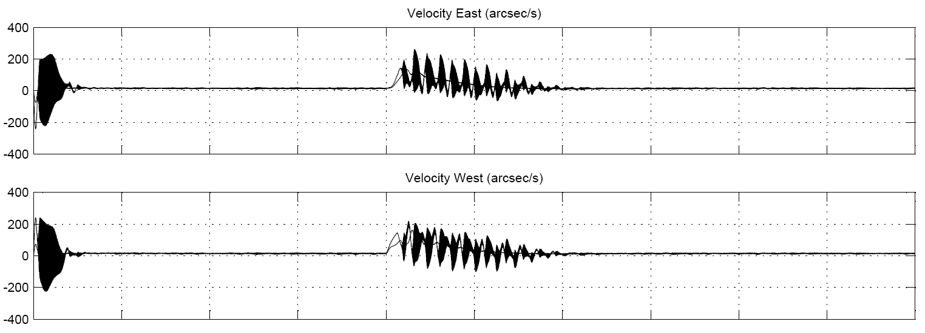

Figure 4 Current TCS1 System SIMULINK Model with Original and Spare Motor

Figure 5 TCS1 System SIMULINK Model with Original and “tuned” system for Spare Motor

Summary
Nothing was found in any analysis that indicates that the spare motors will not match the performance of the original motors. A PSPICE analysis indicated that the spare motors could be more responsive at lower speeds in the range of the telescope operation if required. Keep in mind that the models do not encompass every minute detail and that some simplifications are made, such as the amplifier model, which is idealized. This is one area that is not characterized. However, finding no issues mathematically or in the SIMULINK model is still a positive result that lowers the level of risk associated with the spare motors.

Appendix A

Figure 6 Actual TCS1 SLEW Operation, Velocity and Current

Figure 7 Spare Motor Datasheet (“A” version)

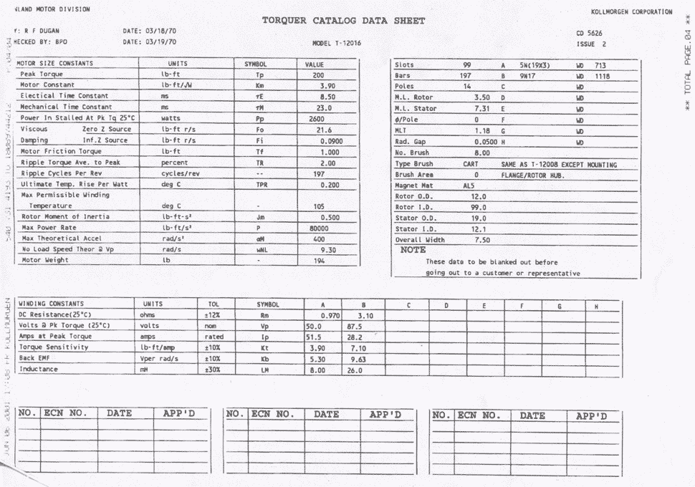

Figure 8 Original Motor Datasheet (“A” version)
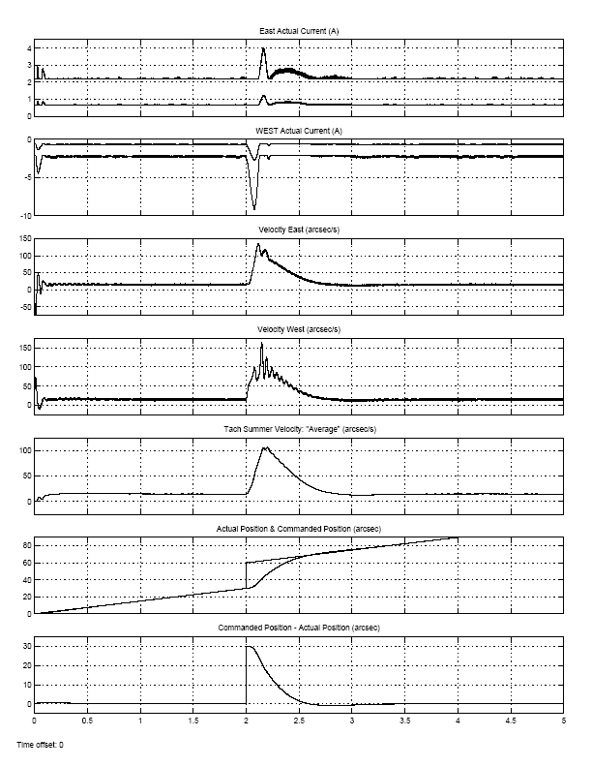

Figure 9 Offset 30 arcsec/s: SIMULINK model of Original and “Tuned” Spare Motor

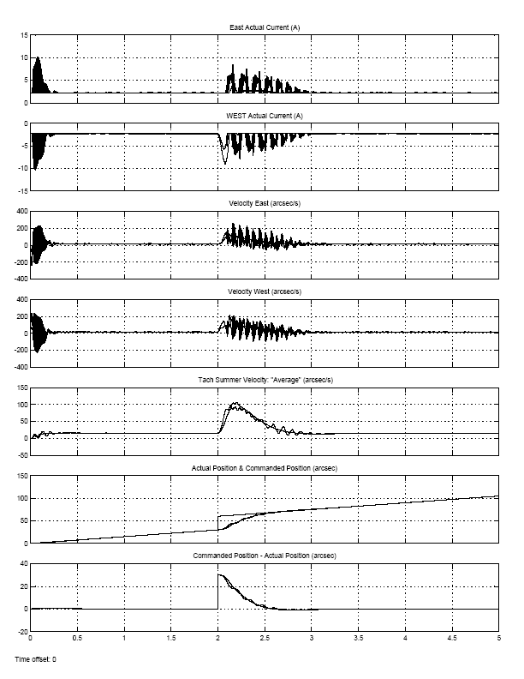

Figure 10 Offset 30 arcsec/s: SIMULINK model of Original and Spare Motor (“not tuned”)

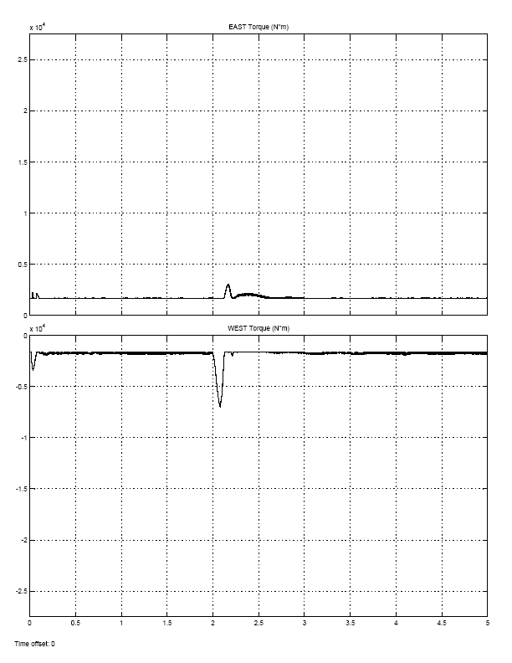

Figure 11 Offset 30 arcsec/s: SIMULINK of Original and “Tuned” Spare Motor Torque

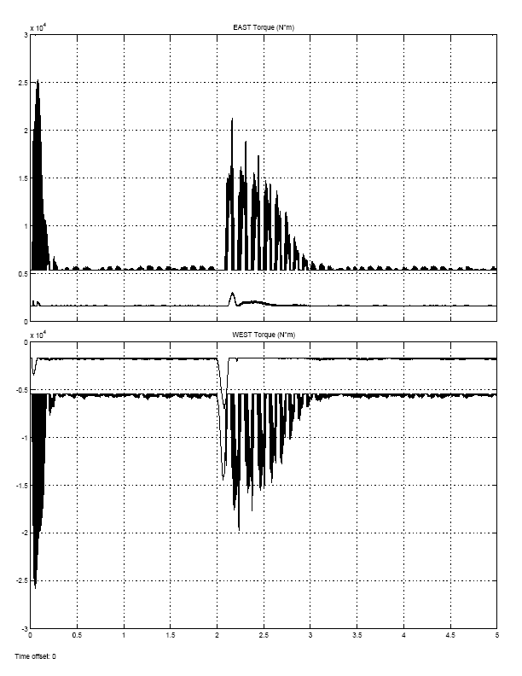

Figure 12 Offset 30 arcsec/s: SIMULINK of Original and Spare Motor Torque (“not tuned”)

References
- Robert E. Cory, “Dynamic Analysis of 3m Mauna Kea Telescope”, jpl Interoffice Memo, November 8, 1976.
- Tim Bond, “TCS Servo System: Mechanical Modeling”, IRTF Document, May 12, 2004, \\duke\tcs3\public_html\systems\tcs3\0405_Servo_review\bond_docs

